Unit 6 Day 11

What do you do at a crosswalk?

First, I look for cars. Then I walk.

Can you say the word **man**? /m/ /a/ /n/

What sound do you hear in the middle of **man**? /a/

What letter is in the middle of **man**?

Can you say the word **jam**? /j/ /a/ /m/

What sound do you hear in the middle of **jam**? /a/

What letter is in the middle of **jam**?

Does **man** and **jam** have the same middle sound?

Yes, **man** and **jam** have the same middle sound.

Does **jam**, **man**, and **mop** have the same middle sound?

No, only **jam** and **man** have the same middle sound.

Read this poem, it is called At the Crosswalk

Here I am at a sign.

Should I walk across this line?

No, red means *Stop!* Green means *Go!*

Look! I can walk safely home!

When you walk up to a crosswalk, you have to stop and look both ways to make sure a car is not coming. If there isn’t a car coming, then you are safe to walk across the crosswalk.

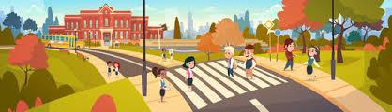

If there is a car coming, then you have to wait until the car passes by you. Once the car is past you and there are no other cars coming, then you can cross the street.

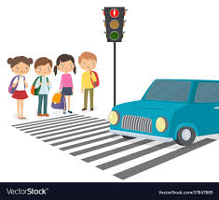

Activities! You are welcome to do all of these activities but please do at least three of them.

1. Have your child write this sentence 4 times each:

I stop at the crosswalk when a car is coming.

1. Have your child write this sentence 4 times each:

I walk across the crosswalk when it is safe to.

1. Have your child draw a picture of themselves at a crosswalk either waiting to cross or crossing the street.
2. Have your child practice these simple sight words 5 times each (know, put, stop, let, walk). This means to say the word, have the child say the word, and write the word.